


Q6. What is the primary goal of Coal India Ltd’s initiative to improve First Mile Connectivity by 2025?
A) Achieving complete mechanization of coal loading and transportation
B) Doubling coal production capacity
C) Expanding coal exports to new markets
D) Replacing all traditional mining methods with automated systems
Q7. By enhancing FMC, how does Coal India Ltd aim to reduce its carbon footprint?
A) By switching to electric trucks for coal transportation
B) By minimizing the use of road transport and maximizing rail transport
C) By using coal with a higher carbon content
D) By planting trees around coal mines

Q8. What is the expected impact of the Gati Shakti plan on the logistics sector in India?
A) Increase in transportation costs
B) Reduction in transportation time and cost
C) Decrease in the use of technology
D) Dependence on traditional logistics methods
Q9. Which of the following sectors is NOT directly targeted by the Gati Shakti plan?
A) Transportation
B) Telecommunications
C) Agriculture
D) Healthcare
Q10. Which technology is widely adopted for real-time monitoring and optimization of coal transportation?
A) Blockchain technology
B) Internet of Things (IoT)
C) Virtual Reality (VR)
D) Augmented Reality (AR)

Q11. How does the use of automated conveyor systems impact coal transportation?
A) It decreases the need for manual labor
B) It increases the efficiency of coal transport
C) It enhances the speed and reduces the cost of transporting coal over short distances
D) It leads to decrease in maintenance costs without benefits

Q12.

Q13.
A simple tableau shown below generated during the maximization of linear programming problem using simplex method.
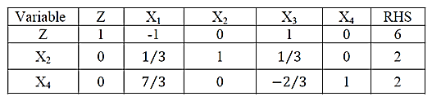
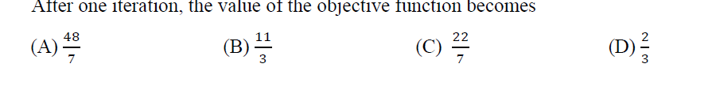

Q14 As shown in the figures below, which of the following sets are convex?

Q15. Consider the following linear Programming problem:
Min Z = βX₁ ₊ 6X₂
Subject to 2X₁ + 2X_{2 ≥} 30
X₁ ≥ 5
X₂ ≥ 5
X_{1,} X₂ ≥ 0

For which values of β is (5,10) an optimal solution?

- 0 ≤ β ≤ 6
- 6 ≤ β ≤ ∞
- 0 ≤ β ≤ 3
- 3 ≤ β ≤ ∞

Q16. Consider the following Linear Programming problem:

Max 4X₁ ₊ 6X₂
Subject to 5X₁ + 5X₂ ≤ 20
2X₁ + 4 X₂

What is the upper bound of the sensitivity range of the coefficient on X₁ in the objective function?

- 4
- 6
- 2
- 3

Q17. What is the upper bound of the sensitivity range of the coefficient on X₂ in the objective function? Based on Q16 above

A. 2
B. 4
C. 8
D. 6

Q18.A pair of feasible solutions of dual canonical linear programming problems exhibit complementary slackness

(a) if and only if they are basic solutions.
(b) if and only if they are basic feasible solutions.
(c) if and only if they are optimal solutions.
(d) cannot be determined

Q19. A linear programming problem having an empty constraint set is said to be
(a) Feasible
(b) Bounded
(c) Unbounded
(d) Infeasible

Q20.
